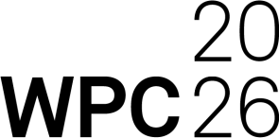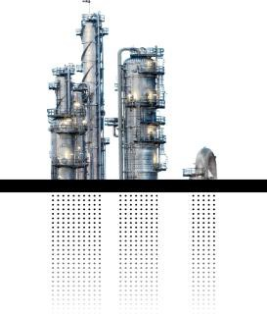
Dear (Manager),
I would like to attend the World Petrochemical Conference by S&P Global, March 23 – 27 2026 in Houston, Texas, an essential forum for gaining strategic market intelligence.
Here are some of the reasons why I think it would be valuable to attend the event:
The WPC 2026 theme will be: "Catalyzing the Transformation: Renewal for Chemicals in an Era of Disruption"
- Access to 1,200+ industry leaders from 50+ countries and 400 companies discussing the latest challenges and opportunities the industry is facing
- WPC week includes data-driven deep dives across the entire chemical value chain: Week at a Glance
- Access to comprehensive coverage of critical topics such as: geopolitics, sustainability, capital strategies, regional trends, supply chain optimization and plastics circularity.
- Direct engagement with industry experts provided actionable intelligence and forecasting. Here’s a breakdown of estimated costs:
- Domestic round-trip airfare estimate (subject to airline prices & availability) $
- Hotel (4 nights at Conference Discount: $410 per night/$1640 + tax and fees
- Registration fee: $2626 (exp 1/26/26) then $2826
- Training Course optional: $1726 (exp 1/26/26) then $1926
WPC 2026 Conference Pass also includes Exclusive Access to the Innovation Agora at CERAWeek on March 25 & 26 for expanded networking and engagement on cross-sector issues. This complimentary access saves up to an additional $3000.
Total: $ (USD) + taxes and fees
The knowledge and connections gained will deliver significant ROI for our organization, informing our strategic planning and competitive positioning.
Thank you for considering my request to attend this event. I am really excited about this prestigious global industry gathering for chemical innovation, insight, and collaboration and look forward to your reply.
(your name)

